**A1.1 Advantages and disadvantages of concrete: -**

* **Concrete: -**

**Concrete** is composite material composed of coarse aggregate bonded together with a fluid Cement that hardens over time. Most concretes used are [lime](https://en.wikipedia.org/wiki/Lime_(material))-based concretes such as [Portland cement](https://en.wikipedia.org/wiki/Portland_cement) concrete or concretes made with other [hydraulic cements](https://en.wikipedia.org/wiki/Hydraulic_cement), such as [ciment fondu](https://en.wikipedia.org/wiki/Calcium_aluminate_cements" \o "Calcium aluminate cements). However, [asphalt concrete](https://en.wikipedia.org/wiki/Asphalt_concrete), which is frequently used for [road surfaces](https://en.wikipedia.org/wiki/Road_surface), is also a type of concrete, where the cement material is [bitumen](https://en.wikipedia.org/wiki/Bitumen), and [polymer concretes](https://en.wikipedia.org/wiki/Polymer_concrete) are sometimes used where the cementing material is a polymer. **Concrete** is **made up** of three basic components: water, aggregate (rock, sand, or gravel) and Portland cement. Cement, usually in powder form, acts as a binding agent when mixed with water and aggregates.

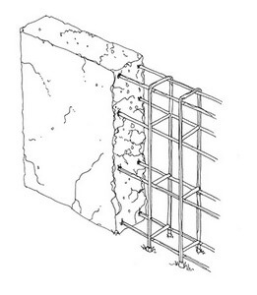

* **Uses of concrete: -**

Life spans for **concrete** building products can be double or triple those of other common building materials. Thermal mass. Homes built with **concrete** walls, foundations, and floors are highly energy efficient because they take advantage of concretes inherent thermal mass or ability to absorb and retain heat.

* **Advantage of concrete: -**
* Ingredients of concrete are easily available in most of the places.
* Unlike natural stones, Concrete is free from defects and flaws.
* Concrete can be manufactured to desired strength with an economy.
* The durability of concrete is very high.
* It can be cast to any desired shape.
* The casting of concrete can be done in the working site which makes it economical.
* Maintenance cost of concrete is almost negligible.
* The deterioration of concrete is not appreciable with age.
* Concrete makes a building fire-safe due to its non-combustible nature.
* Concrete can withstand high temperatures.
* Concrete is resistant to wind and water. Therefore, it is a very useful in storm shelters.
* As a sound proofing material cinder concrete could be used.
* **Disadvantage of concrete**: -
* Compared to other binding materials, the tensile strength of concrete is relatively low.
* Concrete is less ductile.
* The weight of compared is high compared to its strength.
* Concrete may contain soluble salts. Soluble salts cause efflorescence.

**A1.2 Effect of concrete on the Environment: -**

A major component of **concrete** is cement, which has its own **environmental** and social impacts and contributes largely to those of **concrete**. The cement industry is one of the primary producers of carbon dioxide, a potent greenhouse gas. **Concrete** causes damage to the most fertile layer of the earth, the topsoil.

Inhaling high levels of dust may occur when workers empty bags of **cement**. ... Sanding, grinding, or cutting **concrete** can also release large amounts of dust containing high levels of crystalline silica. Prolonged or repeated exposure can lead to a disabling and often fatal lung disease called silicosis.

**A1.3 Justification of stance taken: -**

**B.1**

* **B1.1 Effects of Fracking on soil and ground water table: -**

Fracking is the process of drilling down into the earth before a high-pressure water mixture is directed at the rock to release the gas inside. Water, sand and chemicals are injected into the rock at high pressure which allows the gas to flow out to the head of the well.

Hydraulic fracturing or fracking creates fractures in the shale formation to release the gas. A fracturing fluid is pumped under high pressure (ca. 100 bar) into the drilling pipe to widen fractures in the rock or to create new ones. The fluid consists mainly of water.

**Risk of fracking: -**

* Contamination of groundwater.
* Methane pollution and its impact on climate change.
* Air pollution impacts.
* Exposure to toxic chemicals.
* Blowouts due to gas explosion.
* Waste disposal.
* Large volume water use in water-deficient regions.
* Fracking-induced earthquakes.
* **Effects of fracking on soil: -**
* **Effects of fracking on ground water: -**

Chemical additives are used in the drilling mud, slurries and fluids required for the fracking process. Each well produces millions of gallons of toxic fluid containing not only the added chemicals, but other naturally occurring radioactive material, liquid hydrocarbons, brine water and heavy metals. Fissures created by the fracking process can also create underground pathways for gases, chemicals and radioactive material.

The Environmental Protection Agency [(EPA)](http://yosemite.epa.gov/opa/admpress.nsf/20ed1dfa1751192c8525735900400c30/ef35bd26a80d6ce3852579600065c94e!OpenDocument) and United States Geological Survey [(USGS)](http://pubs.usgs.gov/ds/718/DS718_508.pdf) have recently confirmed what residents of Pavillion, Wyoming had been claiming–that hydrofracking had contaminated their groundwater.

The Environmental Protection Agency (EPA) initially under an [emergency administrative order](https://yosemite.epa.gov/oa/rhc/epaadmin.nsf/Filings/3973BBFC0F02C25F85257B89001BCB0D/$File/SDWA0820130035%20AO.pdf) forced three oil production companies operating on the Fort Peck Reservation, to reimburse the city of Poplar, MT for water infrastructure expenditures incurred as a result of drilling contamination. The oil companies appealed the EPA order, but were forced to rectify their violations by a federal judge.

Another scenario for contamination to occur is by faulty design or construction of the cement well casings–something that happened in the BP Gulf blowout disaster. Storage of the waste water is currently under the regulatory jurisdiction of states, many of whom have weak to non-existent policies protecting the environment.

**B1.2 Methods to overcome the effects due to Fracking: -**

Solving fracking's biggest problem. FORTUNE — One of the big environmental (and financial) challenges the oil and gas industry faces is the amount of water a fracking well requires. In fracking, water is driven under pressure deep into a well.

Not completed

**B2.1 Impact of mobile phones on flora and fauna: -**

The electromagnetic radiation (EMR) emitted from mobile towers is so powerful that it affects the biological systems of birds, insects, and even humans. The study, released by the environment ministry, called for the protection of flora and fauna by law.

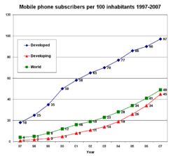

Not completed

**B2.2 Effect of Electromagnetic radiation on Sparrows: -**

The ancient Romans introduced the house sparrow to Europe from North Africa andEurasia. Human exploration and migration then took the bird to many other parts of theglobe, including North and South America, South Africa, India, Australia and NewZealand

"Birds are good ecological indicators for low-intensity electromagnetic radiation, they have thin skulls and their feathers can act as dielectric receptors of microwave radiation. Many species use magnetic navigation and microwaves can interfere with their sensors and misguide them while navigating and preying," Being a social bird, the sparrow thrived around human beings and where grain wasabundant. Despite being derided as ‘avian rat' in the late 19th century (for damaging cerealand other crops), the sparrow steadily ‘colonised' a number of countries. The demise of vastnumbers of this spunky bird is all the more shocking since it is a survivor; sparrows have been found breeding high up in the Himalaya and down below in Yorkshire coal mines.

The electromagnetic radiation emerging from mobile tower and mobile phones has caused thedecline of sparrows. Increasing number of mobile towers in urban and rural areas is affecting the breeding of sparrows. The eggs of sparrows failed to hatch in presence of electromagneticradiation even after a month, though their normal incubation period ranged from 10 -12 days.Apart from this, changing lifestyles and architectural evolution have wreaked havoc on the bird'shabitat and food sources. Modern buildings devoid of eaves and crannies, disappearing homegardens and crop fields cleaned of insects by the use of chemical pesticides, all play a part indenying sparrows nesting sites and food, especially for the young. It is the same sad story for thesparrow all over the globe. To protect the sparrows to become fully out of the world Sacon haslaunched the Common Bird Conservation Programme. This is in addition to the Endangered Species Conservation Programme, which is investigating factors affecting the populations of endangered birds.

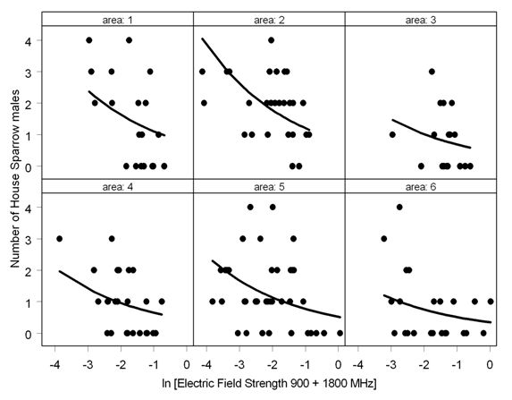

**B3.1 Role of Genetic Engineering the development of a country:-**

**Genetic engineering**, also called **genetic modification**, is the direct manipulation of an organism's [genes](https://en.wikipedia.org/wiki/Gene) using [biotechnology](https://en.wikipedia.org/wiki/Biotechnology). It is a set of technologies used to change the genetic makeup of cells, including the transfer of genes within and across species boundaries to produce improved or novel [organisms](https://en.wikipedia.org/wiki/Organisms).

Genetic engineering has applications in medicine, research, industry and agriculture and can be used on a wide range of plants, animals and micro organisms. [Bacteria](https://en.wikipedia.org/wiki/Bacteria), the first organisms to be genetically modified, can have plasmid DNA inserted containing new genes that code for medicines or enzymes that process food and other [substrates](https://en.wikipedia.org/wiki/Enzyme_substrate_(biology)).[[73]](https://en.wikipedia.org/wiki/Genetic_engineering#cite_note-73)[[74]](https://en.wikipedia.org/wiki/Genetic_engineering#cite_note-74) Plants have been modified for insect protection, herbicide resistance, virus resistance, enhanced nutrition, tolerance to environmental pressures and the production of edible vaccines.[[75]](https://en.wikipedia.org/wiki/Genetic_engineering#cite_note-75) Most commercialised GMOs are insect resistant and/or herbicide tolerant crop plants.[[76]](https://en.wikipedia.org/wiki/Genetic_engineering#cite_note-76) Genetically modified animals have been used for research, model animals and the production of agricultural or pharmaceutical products. The genetically modified animals include animals with [genes knocked out](https://en.wikipedia.org/wiki/Knock-out_mice), [increased susceptibility to disease](https://en.wikipedia.org/wiki/Oncomouse), hormones for extra growth and the ability to express proteins in their milk.

**B3.2 Effect of Genetically Modified Crops on human health: -**

About 10,000 years ago subsistence farmers started to domesticate plants and it was only much later, after the discovery of the fundaments of genetics, those organisms were submitted to rational genetic improvement mainly by selecting of traits of interest. Breeders used appropriate gene combinations to produce new animal races, plant varieties and hybrids, as well as improved microorganisms such as yeasts. After the introduction of recombinant DNA techniques, the transfer of DNA between species belonging to different genera, families or kingdoms became possible. The release of transgenic plants has aroused debates about several aspects of the environmental and human risks that could result from the introduction of genetically modified crops. Less effort has been dedicated to evaluate the impact of transgenic plants on their associated microorganisms, some of which (e.g. nitrogen-fixing bacteria, mycorrhizal fungi and endophytic microbiota) are extremely important for the survival of the plant. Investigations have been made regarding the horizontal transfer of genetic material between transgenic plants and microorganisms and on the disturbance of useful symbiotic associations between plants and endophytic, epiphytic and rhizosphere communities. In most cases the results do no show any adverse effect of transgenic plants on autochthonous plant-associated microorganisms. Results from our laboratory show small changes caused by genetically modified endophytic bacteria on the indigenous endophytic population of the sweet orange Citrus sinensis. In tests using appropriated fungal strains preliminary results using extracts from transgenic plants indicate that these plants do not affect haploidization, mitotic crossing-over, mutation rate or chromosomal alterations.

 More than 85 percent of the corn and soy grown in the United States comes from seeds whose DNA has been rejiggered (to increase yields), and those two crops play starring roles in countless processed foods, from soda to salad dressing to bread. Advocates say genetically modified (GM) foods allow farmers to produce more with fewer chemicals—which means a cleaner environment and cheaper groceries for us all.

Genetically modified (or GM) plants have attracted a large amount of media attention in recent years and continue to do so. Despite this, the general public remains largely unaware of what a GM plant actually is or what advantages and disadvantages the technology has to offer, particularly with regard to the range of applications for which they can be used. From the first generation of GM crops, two main areas of concern have emerged, namely risk to the environment and risk to human health. As GM plants are gradually being introduced into the European Union there is likely to be increasing public concern regarding potential health issues. Although it is now commonplace for the press to adopt ‘health campaigns’, the information they publish is often unreliable and unrepresentative of the available scientific evidence. We consider it important that the medical profession should be aware of the state of the art, and, as they are often the first port of call for a concerned patient, be in a position to provide an informed opinion.

 Three aspects of this procedure have raised debate with regard to human health.

* The use of selectable markers to identify transformed cells
* Transfer of extraneous DNA into the plant genome (i.e. genes other than those being studied)
* The possibility of increased mutations in GM plants compared to non-GM counterparts due to tissue culture processes used in their production and the rearrangement of DNA around the insertion site of foreign genes.

In the developing world, 840 million people are chronically undernourished, surviving on fewer than 8000 kJ/day (2000 Kcal/day).[14](https://www.ncbi.nlm.nih.gov/pmc/articles/PMC2408621/#b14),[15](https://www.ncbi.nlm.nih.gov/pmc/articles/PMC2408621/#b15) Approximately 1.3 billion people are living on less than US$1/day[16](https://www.ncbi.nlm.nih.gov/pmc/articles/PMC2408621/#b16),[17](https://www.ncbi.nlm.nih.gov/pmc/articles/PMC2408621/#b17) and do not have secure access to food.

GM crops are tightly regulated by several government bodies. The European Food Safety Authority and each individual member state have detailed the requirements for a full risk assessment of GM plants and derived food and feed.

Any adverse effects on the environment through the large-scale growth of GM plants may indirectly affect human health. The following concerns have been expressed with regard to GM plants and the environment:

* That GM plants will sexually hybridize with non-GM plants through the transfer of pollen
* That GM plants may themselves become invasive weeds
* That the conditions required to grow GM plants will affect local wildlife populations.

**B4.1 Causes for change in climate: -**

**Global warming**, also referred to as **climate change**, is the observed century-scale rise in the average temperature of the [Earth](https://en.wikipedia.org/wiki/Earth)'s [climate system](https://en.wikipedia.org/wiki/Climate) and its related effects.[[1]](https://en.wikipedia.org/wiki/Global_warming#cite_note-1)[[2]](https://en.wikipedia.org/wiki/Global_warming#cite_note-2) Multiple lines of scientific evidence show that the climate system is warming.[[3]](https://en.wikipedia.org/wiki/Global_warming#cite_note-3)[[4]](https://en.wikipedia.org/wiki/Global_warming#cite_note-4)[[5]](https://en.wikipedia.org/wiki/Global_warming#cite_note-5) Many of the observed changes since the 1950s are unprecedented in the [instrumental temperature ecord](https://en.wikipedia.org/wiki/Instrumental_temperature_record)which extends back to the mid-19th century, and in [paleoclimate](https://en.wikipedia.org/wiki/Paleoclimatology) [proxy records](https://en.wikipedia.org/wiki/Proxy_(climate)) covering thousands of years.

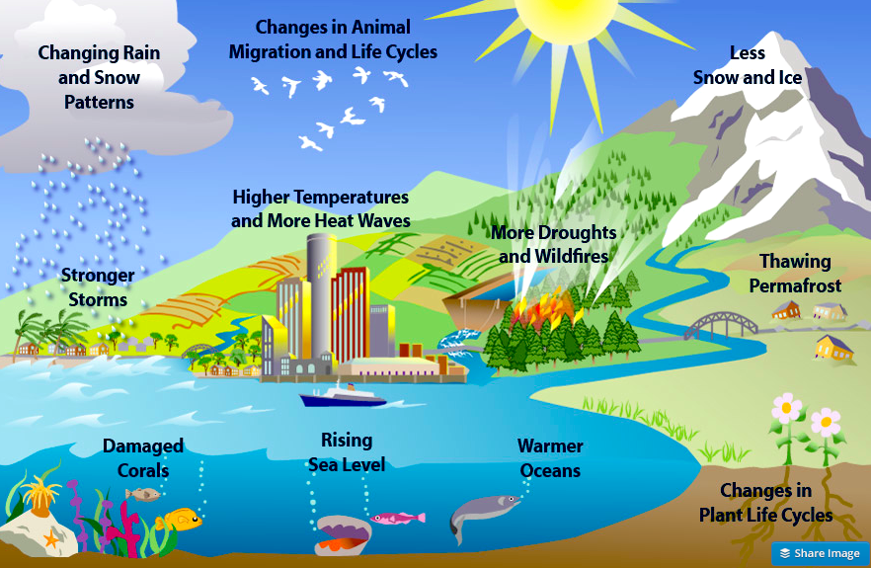

The earth's climate is dynamic and always changing through a natural cycle. What the world is more worried about is that the changes that are occurring today have been speeded up because of man's activities. These changes are being studied by scientists all over the world who are finding evidence from tree rings, pollen samples, ice cores, and sea sediments. The causes of climate change can be divided into two categories - those that are due to natural causes and those that are created by man.

Earth's temperature depends on the balance between energy entering and leaving the planet’s system. When incoming energy from the sun is absorbed by the Earth system, Earth warms. When the sun’s energy is reflected back into space, Earth avoids warming. When absorbed energy is released back into space, Earth cools. Many factors, both natural and human, can cause changes in Earth’s energy balance, including:

* Variations in [the sun's energy](https://19january2017snapshot.epa.gov/climate-change-science/causes-climate-change_.html#Sun) reaching Earth
* Changes in the [reflectivity](https://19january2017snapshot.epa.gov/climate-change-science/causes-climate-change_.html#Reflectivity) of Earth’s atmosphere and surface
* Changes in the [greenhouse effect](https://19january2017snapshot.epa.gov/climate-change-science/causes-climate-change_.html#Greenhouse), which affects the amount of heat retained by Earth’s atmosphere.

**Human sources**

* Changes in greenhouse gas concentrations
* Deforestation and land use changes
* Sulfate aerosols
* Soot particles (black carbon)

**Natural sources**

* Variations in the Earth's orbital characteristics
* Volcanic eruptions
* Variations in solar output
* Natural aerosols

These factors have caused Earth’s climate to change many times.

Scientists have pieced together a record of Earth’s climate, dating back hundreds of thousands of years (and, in some cases, millions or hundreds of millions of years), by analyzing a number of indirect measures of climate such as ice cores, tree rings, glacier lengths, pollen remains, and ocean sediments, and by studying changes in Earth’s orbit around the sun.

This record shows that the climate system varies naturally over a wide range of time scales. In general, climate changes prior to the Industrial Revolution in the 1700s can be explained by natural causes, such as changes in solar energy, volcanic eruptions, and natural changes in greenhouse gas (GHG) concentrations.

Recent climate changes, however, cannot be explained by natural causes alone. Research indicates that natural causes do not explain most observed warming, especially warming since the mid-20thcentury. Rather, it is extremely likely that human activities have been the dominant cause of that warming.

**B4.2 Methods to create awareness among people about climatic change: -**

**Well to start with we all know global warming is as big a threat to the world as is terrorism. We all worry, take some actions and then are left clueless how to proceed? Time is to spread awareness and that we can do.**

It has to start at home. Educate and practice, that is the only way it can be inculcated into the psyche of people. We all have to contribute to it, not only the government. We all always try to do things easier way. But if we first start thinking about our convenience and the environment for any action that we do probably it will help. So the change has to come in the way people start thinking about it. A few things probably we all develop that will help environment.

1. Reduce, Reuse and Recycle – the three R’s

2. Use as far as possible locally produced groceries, goods and services.

3. Make each community as self-supporting as possible.

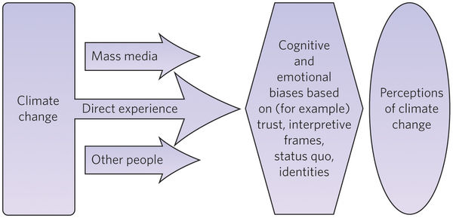

It should involve planning, action, and communication of the specific idea concerned related to environmental protraction, its logic, and how it will benefit people. It should involve short-term and long-term measures. The following can be done in this regards:

--Make it one of the top priority of the government

--It should be taught to all children from primary to middle class as core subject

--This should not be just symbolic; but must imbibe instilling a realistic concern in all children

--There should be awards and recognition for children who show good work in this regard

--Promoting the idea through stories as ads on TV and radio

--Planting saplings of trees; every tree cut for development projects must be replaced by planting at least 50-100 saplings.

--Participating by government at international level and adopting the action plan in government policies

--Awards, recognition and incentives for industrial set ups at green sites, and those who take initiatives for environment protection

1. **Bring the change in you.** Avoid plastics by all the means one could.
2. **Plant as many trees and plants as your space permits.**
3. **Terrace gardens are a big advantage for people living in cities with limited garden space.**
4. **Contact your nearby clubs and conduct awareness classes in nearby schools and your locality.**
5. **Make a bigger move by joining hands with NGOs and local authorities to plant more trees.**
6. **Promote the usage of public transport to private vehicles.**
7. **Encourage people to use cycles.**
8. **Conduct exhibitions in public halls that focuses on the increased natural calamities due to climate imbalance.**

This measure encompasses actions that promote awareness for the altered conditions under climate change and adaptation. However, not all stakeholders are aware and informed about their vulnerability and the measures they can take to pro-actively adapt to climate change. Awareness raising is therefore an important component of the adaptation process to manage the impacts of climate change, enhance adaptive capacity, and reduce overall vulnerability.

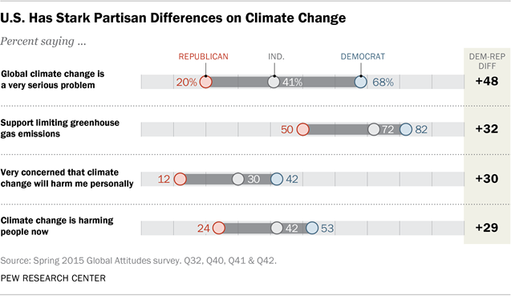

"Birds are good ecological indicators for low-intensity electromagnetic radiation, they have thin skulls and their feathers can act as dielectric receptors of microwave radiation. Many species use magnetic navigation and microwaves can interfere with their sensors and misguide them while navigating and preying," "Birds are good ecological indicators for low-intensity electromagnetic radiation, they have thin skulls and their feathers can act as dielectric receptors of microwave radiation. Many species use magnetic navigation and microwaves can interfere with their sensors and misguide them while navigating and preying," "Birds are good ecological indicators for low-intensity electromagnetic radiation, they have thin skulls and their feathers can act as dielectric receptors of microwave radiation. Many species use magnetic navigation and microwaves can interfere with their sensors and misguide them while navigating and preying," "Birds are good ecological indicators for low-intensity electromagnetic radiation, they have thin skulls and their feathers can act as dielectric receptors of microwave radiation. Many species use magnetic navigation and microwaves can interfere with their sensors and misguide them while navigating and preying," "Birds are good ecological indicators for low-intensity electromagnetic radiation, they have thin skulls and their feathers can act as dielectric receptors of microwave radiation. Many species use magnetic navigation and microwaves can interfere with their sensors and misguide them while navigating and preying,"

"Birds are good ecological indicators for low-intensity electromagnetic radiation, they have thin skulls and their feathers can act as dielectric receptors of microwave radiation. Many species use magnetic navigation and microwaves can interfere with their sensors and misguide them while navigating and preying,"